DeShaun Riddick Traffic Systems

Project Close Out

DeShaun Riddick, PROJ Mgr.
DeVry
Project Management Systems - 586/10026
Festus Elleh, PhD
06/22/2024

Table of Contents
Section I: Executive Overview 3
Section II: Project Management Discipline Alignment 4
Section III: Effects of Sociocultural Factors 5
Section IV: Leadership and Professional Conduct 6
Section V: Conclusion 8
References 9
Appendix
Project Charter 10
Scope Statement 14
WBS 16
Project Schedule 17
Communications Management Plan 18
RAM or RACI matrix 26

Executive Overview
Traffic is a company that is based in the New York, Hauppauge area. The organization has 100+ employees. With the current threat of outdated infrastructure collapsing in our area, Traffic needs to abide by the NY State Guidelines from President Biden. Funding for the project is provided by the US infrastructure bill. This is an opportunity to introduce a reduction in traffic collisions, add jobs to the community and “improve traffic management,” according to a White House Statement released from the Briefing Room on January 25, 2024. Managing project complexity and risk, the issues of an abundance of traffic collisions can be mitigated coupled with creating a collaborative project team environment that brings value to the citizens, community and State.
Navigating complexity will be my task as Project Manager. Having this uncertainty of how real time events such as acts of God impact traffic management is yet to be qualified. With great work life balance and meaningful pay scale and promotion from within, this should foster positive human behavior while the project runs its course. Policy and guidance on handling subcontractors and vendors interaction will help mitigate conflict. Frederick Taylor firstdeveloped a methodolgy for breaking down work into its most minor movement with a stopwatchduring the Steel Mill Projects 1950s. (elleh, 2023, p. 79)

Project Management Discipline Alignment

Traffic Management is an integrated style of project, product and program management that provides a service. This project for Traffic Signals Lights (TSL) process has a repetitive life cycle. The product being a program managed within a program. The alignment the New York State Department of Transportation (NYSDOT) has with the modernity of project management disciplines shows how the program Mio Vision is managed software as a service (Saas). This software manages the intersection with video camera technology that feeds data back to the IT Dpt. Via modem communication. By defining these and summing up the associated costs of each operation, the costs for the new product can be estimated (Hueber et al., 2016).

The Traffic Rehabilitation Project (TRP) overall encompasses the Saas integrated into the intersection that is in sync with the TSL at each phase. The product or output of the project is lives being saved and less vehicular crashes and smoother travel time due to less congestion. The beauty in the integration of the finished project is that the life cycle can be repeated at a new intersection. The impact on the community is second to none. From the project charter, scope to the retirement of the project, the business system is duplicable with lessons learned and documentation of approval of the product, any one of those PM styles can be expanded or focused on one area Beit service, product or project.

Effects of Sociocultural Factors
There are several reasons why projects fail and just as many more why they are successful. For the PM working with the TSL groups to rehabilitate Nassau and Suffolk County in NY, diversity is inevitably incorporated in the workforce. The benefits outweigh the lessons learned from working with different ethnic backgrounds. Working in Lake Success is a great example of how having a diverse team improves the project, community and save lives.
There is a synagogue in Lake Success and our TSL is at Lakeville Rd. @ I -495. When the traffic light becomes compromised, technicians are immediately dispatched for repair. Unfortunately, if it happens during an event like a bar mitzvah, traffic can become congested or voluminous for miles onto the service road back to the main artery. A few technicians happened to be familiar with the Rabbi of the synagogue. He explained the TSL that could not be fixed expediently because this is an intersection that was slated for rehabilitation. The Rabbi was very understanding and thankful for the advanced warning of the construction to take place and relocated all events. This made traffic patterns very light.
The challenges with diverse teams who are not natural born citizens is the safety precautions used for bridges/tunnels, and highway corridors. Often in the first few weeks to months we buddy the technicians with someone who can explain the road to them in a way that they can understand public safety. The onboarding process we invented has proven successful versus the old way of trial by fire. The department lost life and assets when workers rode the highway and did not have a clear understanding of navigating the highway and service road safely. Some countries ride the road on the opposite side of the road. Our kick-off training addresses these areas and helps the technicians get a CDL license. Safety is the number one concern. NYSDOT is proven to be a responsive reliable employer who benefits the public first!
Leadership and Professional Conduct
I believe that the leadership must have a plan of direction. The leader must have vision to accompany the planned direction of the project. My visionary leadership style is best suited for the NYSDOT project because the goal is to save lives, reduce crashes, and improve travel time. I have very clear directions and guidance passed down to me from the governor. Breaking down the work into structured processes into clear direction and milestones for Suffolk/Nassau County is what will keep the project on track. As we approach the milestones, we will celebrate with BBQ food in the state parks for the workers.
I provide an authoritative style because in some respects we are the law. Having an exceptional sense for what motivates individuals to be accountable for deliverables is my strength on project teams. As intersections that have a red-light camera need to follow the governance and CAD design, challenges can arise. Delegating the IT resources for provision of the Mio Vision that gives a competitive edge to intersection detection. Thus, yielding a safer pedestrian crossing intersection through camera detection.
A project manager applies leadership skills and qualities when working with all project stakeholders, including the project team, the steering team, and project sponsors (Percipio, n.d., sec. 3.4.4.1).
Being able to lead, motivate and solve problems that are personal issues of your team or just being a listening ear. All these qualities I believe are what makes a good leader great. Maintaining the human element and not being a dictator. As PM program management is the oversight of a conglomerate of individual projects that are under the stewardship of the program manager. Managers use their position of power to direct, maintain, administrate and focus on systems and programs and projects. Although leadership is interchangeably used with Project Manager, to be successful. Dealing effectively with people and managing those relationships is what also makes the operation successful and weeds out contention. Personality clashes can mean losing a key player in the project for example. The style of leadership matters just as much as knowing the people you are directing. Leaders of these programs, individual projects and portfolios must have the knowledge, skills, tools and technique to report reasons for success and not failure. Leader characteristics (e.g., attitudes, moods, needs, values, ethics); (Percipio, n.d., p. 3.4.5.1)
- Servant leader (e.g., demonstrates commitment to serve and put other people first; focuses on other people's growth, learning, development, autonomy, and well-being; concentrates on relationships, community and collaboration; leadership is secondary and emerges after service); (Percipio, n.d., p. 3.4.5.1)
Having documentation for every time a status update is sent is part of being accountable. As PM, creating a procedure and or policy for actionable items is best practice for keeping teams accountable.

Conclusion
There are some lessons that have been learned throughout this project that are valuable.
Diversity is important on the project to gain different perspectives that can improve the flow of how a project is impacted by community locals. The synagogue Rabbi was kind enough to relocate slated events to decrease traffic delays for the rehabilitation of the intersection. Thanks to a few Nassau technicians who attend the house of worship. Budget accuracy is paramount for funding the projects properly. As this project was underfunded in the beginning, we had to increase the budget to meet the project scope. Approvals were granted and it did push the project completion date out by 4 days. It is better to have a larger budget than to be underfunded. Keeping accurate records for future reference and to turn in at the completion of the project to auditors is a best practice.
Strengths | Improvements | Do differently | Don’t Change
Quality assurance of product | Budget analysis due to underfunding the project. | Have more human capital for contract work | Diversifying the staff
Clear concise Communication of schedule build outs | Keeping digital records instead of paper. | Better productive meetings instead of quarrelsome interdepartmental speak | Celebration of achievements and goals set
Diversity | Celebrating more achievements besides milestones to keep moral high | Use outside auditor instead of Risk Management department | Keeping awesome minutes and approvals for scope changes

Reference

Percipio. (n.d.). https://devry.percipio.com/books/36fdea70-aa2d-11e7-9c7a-4e99e0664338#epubcfi(/6/128!/4/2%5Bepubmain%5D/2%5Bpt01ch11lev1sec7%5D/2/2/1:0)
Elleh, F. (2023). Project Management: Waterfall-Agile-IT-Data Science.
Hueber, C., Horejsi, K., & Schledjewski, R. (2016). Review of cost estimation: methods and models for aerospace composite manufacturing. Advanced Manufacturing. Polymer & Composites Science, 2(1), 1–13. https://doi.org/10.1080/20550340.2016.1154642
Percipio. (n.d.). https://devry.percipio.com/books/36fdea70-aa2d-11e7-9c7a-4e99e0664338#epubcfi(/6/128!/4/2%5Bepubmain%5D/2%5Bpt01ch11lev1sec7%5D/2/2/1:0)
Sebastian. (2023b, August 19). Analogous Estimating | Definition, Examples, Pros & Cons. Project-Management.info. https://project-management.info/analogous-estimating/#6-how-do-you-apply-analogous-estimating
Percipio. (n.d.). https://devry.percipio.com/books/36fdea70-aa2d-11e7-9c7a-4e99e0664338#epubcfi(/6/128!/4/2%5Bepubmain%5D/2%5Bpt01ch11lev1sec7%5D/2/2/1:0)
Skinner, L. J. (2022). How Will AI Transform Project Management? ITNOW, 64(2), 14–15. https://doi.org/10.1093/itnow/bwac040
Niederman, F. (2021). Project management: openings for disruption from AI and advanced analytics. Information Technology & People, 34(6), 1570–1599. https://doi.org/10.1108/itp-09-2020-0639
Transportation Rehabilitation

Project Charter

Project Name | Transportation Rehabilitation
Project Sponsor | Federal Government
Project Manager | DeShaun Riddick

Business Mission | Abide by the NY State Guidelines from President Biden. This is an opportunity to introduce a reduction in traffic collisions, add jobs to the community and improve traffic management.
Business Objective | - Save lives  - Reduce accidents  - Reduce travel time  - Reduce fuel consumption  - Improve congestion mitigation  - Have a positive impact on the community  - Improve Data collection methods
Requirements | Need to look at how many CCTV is ideal  How many the stakeholders will approve  Need to check on how much the technical systems infrastructure, human capital cost.
Major Risk | Supplier is not able to handle the large order  Parts out of manufacture production  Inconvenience to motorist  Damage to ecosystem  Disruption to neighborhood, noise complaints, vehicle damage, theft of construction equipment, temporary power outages
Assumptions | Mio Vision is video observation of traffic intersections real time. Deployment of this system will shorten delays. Regulatory conditions will not impact deployment of the cameras.
Budget | Average cost is $2.8 million dollars
Approval Requirements | President Biden, Governor Hochul & Commissioner Maria Dominguez
Product Scope | Reduce traffic crashes and replace outdated traffic systems & install traffic lights.
Milestones | Milestone one: Beginning May 7, 2024, and ending June 22, 2024. Acquiring subcontractors  Milestone two: Selectin a group of 30 electricians to maintain the physical assets. May 7, 2024, and ending June 22, 2024.  Milestone three: All employees are trained on the new equipment for Traffic CCTV Mio Vision
Schedule  Constraints | Infrastructure completion by May 6, 2025  Funding approved as of May 7, 2024  Training starts June 23rd 2024
Approval By key  stakeholders | President Biden  NY Governor Hochul  NY Commissioner Maria Dominguez

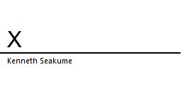5/07/24

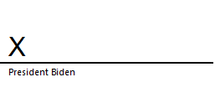5/07/24

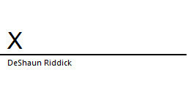5/07/24

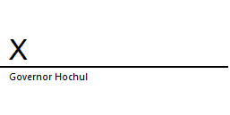5/07/24

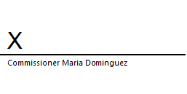5/07/24
Project Scope Statement

Project Name | Transportation Rehabilitation | Project  Number | D#4951685
Project Manager | DeShaun Riddick | Prioritization | High
Owner(s) | President Biden, Governor Hochul, Commissioner Maria Dominguez

Statement of Maintain Cabinets (contains electrical components that control the traffic lights)
Work Project IT will Update & replace computer software drivers to the cabinet. Rebuild traffic signal heads.
Description & We intend to rehab NY Long Island, Nassau/Suffolk County intersections. By making them efficient to
reducing the
Project delays, car crashes & travel time. We will accomplish this rehabilitation through policy, quality.
Product audits, training, meetings, good community press & procedure. At completion, both counties will
have a reduction in crashes, delays will be less than a ¼ of a mile on state roads.

Project Citizens will have a website & telephone number to report faulty traffic lights malfunctioning. Reduction
Deliverables in fatal crashes, DOT resources deployed to address crashes. MIO Vision deployment. Traffic management
Center Organizational hierarchy established, kick off meeting.
Project Beginning May 7, 2024, & ending June 22, 2024. Acquiring subcontractors
Objectives Selectin a group of 30 electricians to maintain the physical assets. May 7, 2024, ending June 22, 2024.
All employees are trained on the new equipment for Traffic CCTV Mio Vision.
Budget: $2.8 million spent on salary, Assets, & subcontractors.
Quality Objectives are to adhere to less than 2 minutes wait time at large intersections & 1 minute at
smaller. Customer/Citizen satisfaction metrics gauged in 90% repeat calls for faulty timing complaints at
intersections Maintain adherence to industry standards & regulatory requirements throughout the project
lifecycle.
Project Resource availability-The NYDOT Region 10 has the available materials to complete the project. (90%)
is in stock.
Assumptions Stakeholder Support- Key stakeholders, sponsors, & media will support the project.
Market Conditions- Stable conditions will remain. As the initiative sent down from President Biden,
there’s a demand.
Technology infrastructure-Software, Computers, & Memories/Servers are in good condition to support
Mio Vision
Acts of God- The Kick-Off meeting will be in the summer (June). We do not anticipate a rainy summer.
Risk- Not enough budget to cover the project once inventory is depleted, overtime is needed, & materials.

Project Limitations, Inventory, supplier backorder, manufacturer product back order for software
Constraints with shortage of components, & budget is thin by $8.8 million.
Exclusions Audio Training Manual- Time consuming. Employees can refer to Handbook or procedures online for
help.
Post Training- SAAS (software as a service) platform support upon completion of the project is not
available.
Acceptance Performance-Final product must exceed or meet the stress test levels for the benchmark at the
Criteria required outlined objectives.
Reliability- Final product must function with minimal to none defects in real world scenarios.
Documentation-user manuals, installation guides & technical support provisions are paramount for
deployment & Maintenance of the final product Mio Vision.

Approvals
Names | Signature | Date
Owner: Kenneth Seakume |  | 5.19.2024
Stakeholder: |  | 5.19.2024
Project Mngr. Approval: |  | 5.19.2024
Sponsor Approval: |  | 5.19.2024
Sponsor Approval: |  | 5.19.2024

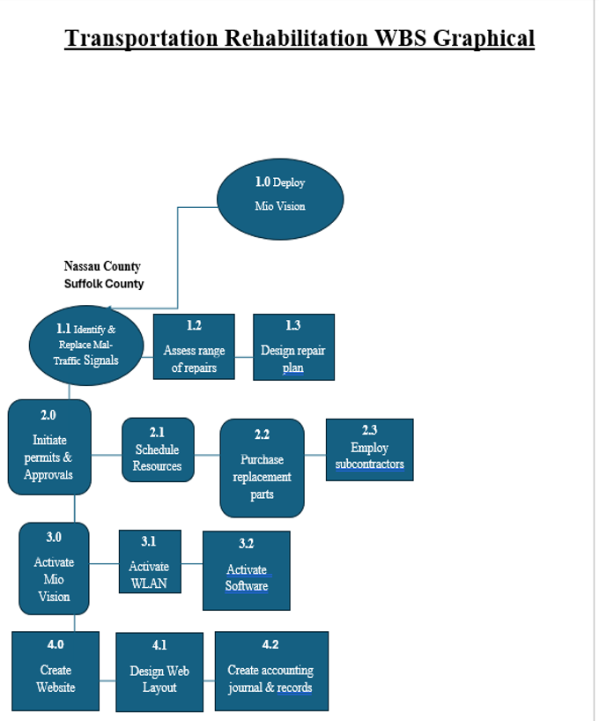

Project Schedule

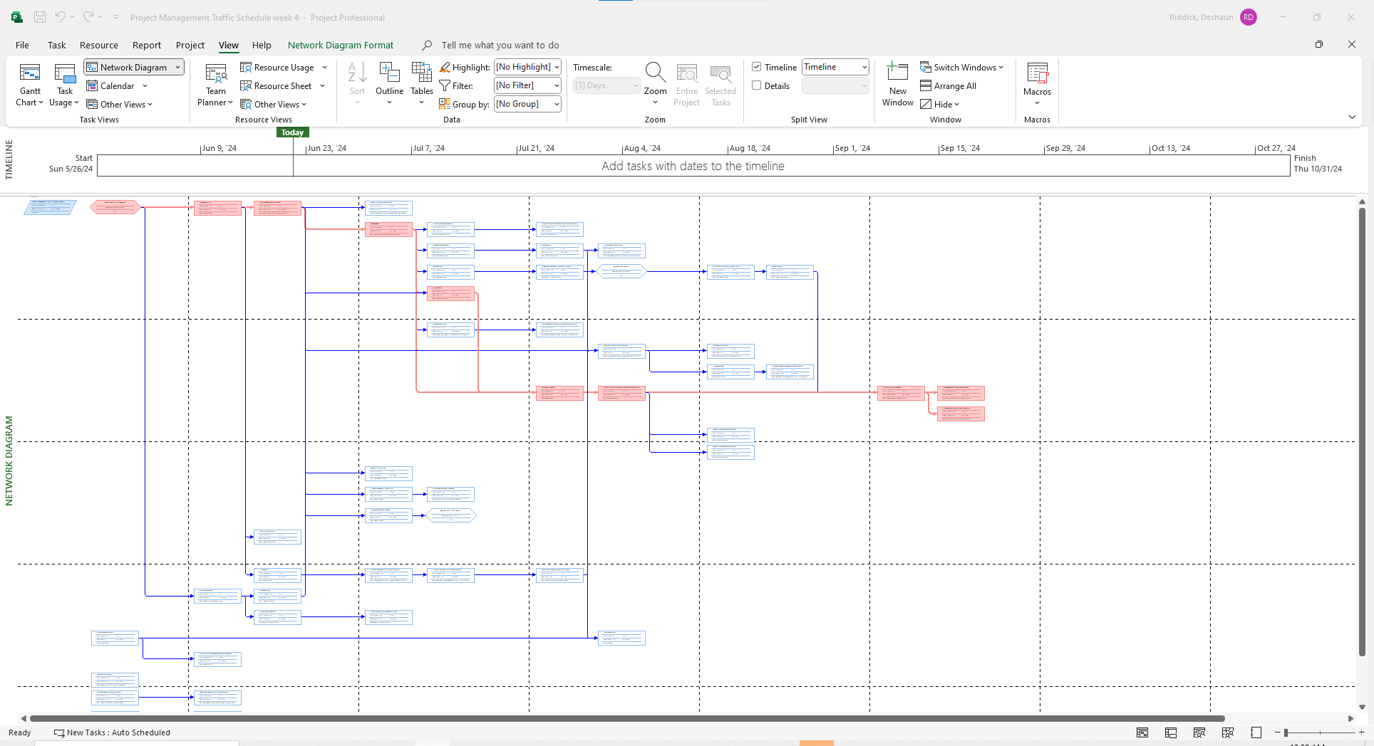

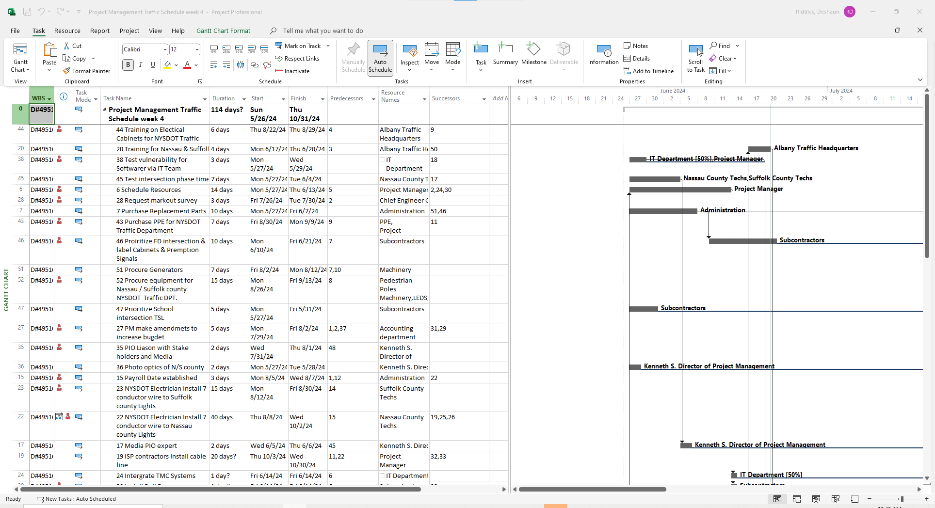

Transportation Rehabilitation Project/NYSDOT

Communications Management Plan

Overview
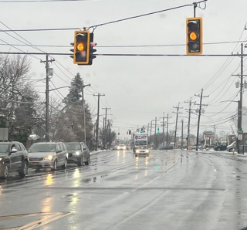

The purpose of this communications managements plan is to document the key elements of the Transportation Rehabilitation Project communications strategy:

Meeting will be conducted utilizing the software below:

- Every second Tuesday of the month at 09:00
- Microsoft Outlook, Teams/Chat, Calendar
- Stakeholders; internal, external partners
- Formal
- Kenneth Seakume

Effective communication can be:

- formal or informal;
- verbal or written; and
- periodic or as needed.

New York State Transportation Rehabilitation
| Communication Plan

This project details planning and executing a comprehensive New York State Transportation Rehabilitation plan for the Long Island Transportation Management Center (TMC). We have identified organizational roles and responsibilities within this Transportation Rehabilitation (TR) plan document as you will see in the matrix below. There will be a Tabletop Exercise on June 23rd, 2024, which will include all project stakeholders, internal, and then external to include the client. Monthly (every 2nd Tuesday) meetings will continue throughout the life cycle of the project. Advanced notification will be given for any changes to the former.
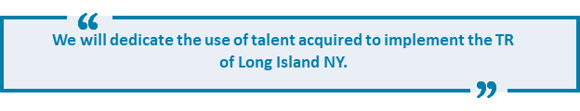
We will dedicate the use of talent acquired to implement the TR of Long Island NY. Every State-of-the-Art technology available to us, primary Microsoft Teams for virtual formal meetings, E-Mail for formal project communication, MS Outlook Chat Room/Groups for quick informal communication, and SharePoint behind MS Teams to store project documents. Anytime a stakeholder is not required for a meeting, the Project Manager (DeShaun Riddick) will list them as an optional attendee in the MS Calendar Invitation.
E-Mail is the face of our internal (President Biden & Governor Hochul) and will likely be the most used technology to coordinate this event aside from telephony. A monthly summary E-Mail will be provided to the team by DeShaun Riddick that will detail milestone project updates, budget burn rate (BBR) and action items. All E-Mails related to this project shall have the Project Number or Permit number (D#4951685) in the header of the E-Mail. A carbon copy will also be delivered to the project archive records E-Mail LITR@DOT.NY.Gov. A LITRNY.Gov site will be created and named D#4951685. A directory of folders will be organized by DeShaun Riddick. Updates to folders and documents notifications will be threaded to the PM.

In addition to the Organizational Roles identified above, each project will include the following roles:
- Kenneth Seakume is the Director of Project Management (DOPM) (TR). He is the principle of this process accountable for contractual implementation, analysis, and maintenance for the project's life cycle.
- DeShaun Riddick is the Project Manager (PM) He is accountable for assuring all the requirements for project communication are contractually in lockstep with this procedure. He is accountable for the communication too and implemented by the team.
- Abnon Muhammad is the Chief Engineer Charge (CEC) He is accountable for the requirements for project communications are met in accordance with this procedure.
- IT Team Members are responsible for the generation and preservation of communications in accordance with this procedure. The IT Team will be the central point of contact for filing and maintaining the project communication files, electronic and hardcopy.

A Matrix of Written and Verbal Communication.

VERBAL COMMUNICATION
WHAT | WHEN | WHERE | OWNER | ATTENDEES
Stakeholders  Status meeting | Monthly  2nd Tuesday  0900 | In the Bubble conference room, in person. Hauppauge NY | Kenneth Seakume | EIC, DOPM, PM, CEC, PSA, Traffic Signal Foremen for Nassau and Suffolk County

WRITTEN COMMUNICATION
WHAT | WHEN | METHOD OF DELIVERY | SENDER | RECEIVER
Project Team  Update meeting | Weekly  Thursdays  0800 | MS Teams, Zoom, E-Mail  Memos | Project Manager  DeShaun Riddick | Nassau & Suffolk County Signal Technicians

Communications Management Plan:

This document outlines the plan of communication for the Transportation Rehabilitation Project Team.

WHAT | WHEN | WHERE | OWNER | ATTENDEES
Status Meeting | Every 2 weeks  Monday  10-noon | Bubble | Kenneth Seakume | Project Team
Called Meetings | As Needed | Monthly  2nd Tuesday  0900 | Person who calls and leads meeting | PM DeShaun Riddick

WRITTEN COMMUNICATION
WHAT | DUE WHEN | METHOD OF DELIVERY | SENDER | RECEIVER
Meeting Minutes | Two days after the meeting | E-Mail | Note Taker | IT Team & attendees
Action Item Log | Four days after the PMO Status meeting | E-Mail | Note Taker | IT Team & attendees
Meeting Agenda | Two days before a meeting | E-Mail | Meeting Facilitator | IT Team & attendees
Status Reports to Project Manager | Weekly  Tuesday  By noon | Paper Copy | Team Members  Nassau/Suffolk | Project Manager
Status Reports to Strategic Alignment Team | Every 2 weeks  Tuesday and Thursday  By COB | E-Mail | DeShaun Riddick PM | Albany NY
Project Schedule Updates | Every 2 weeks  Tuesday  By COB | Update Project Schedule then E-mail | Team Members | DeShaun Riddick PM  Kenneth Seakume (DOPM)

I believe that a Pure Product Projectized structure will best suit the organization because of the effectiveness of direct rapport will foster bonds and expedition response times to emergencies that require a sense of urgency. Here in this setup Kenneth maintains control of the product along with the PM. The goal is to revamp the Traffic Lights and Travel Time, thus yielding a safe commute for motorists and lives saved.

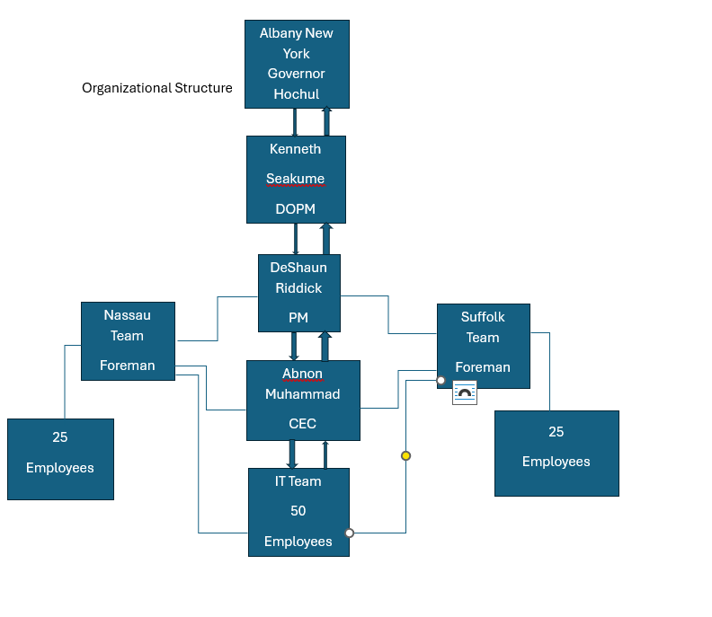

RACI CHART
